Parish Lay Ministries

There are numerous opportunities to share your gifts and talents to support the activities within our parish of Our Lady and St Bridget’s.
“Many hands make light work” – The greater the number of people involved means less of a burden on individuals. There is no need to wait to be asked, please volunteer.
We are all part of the church community.
‘Here am I among you as one who serves’ (Lk.22:27)
‘Each one should use whatever gift he has received to serve others, faithfully administering God’s grace in its various forms.‘ (1 Peter 4:10)

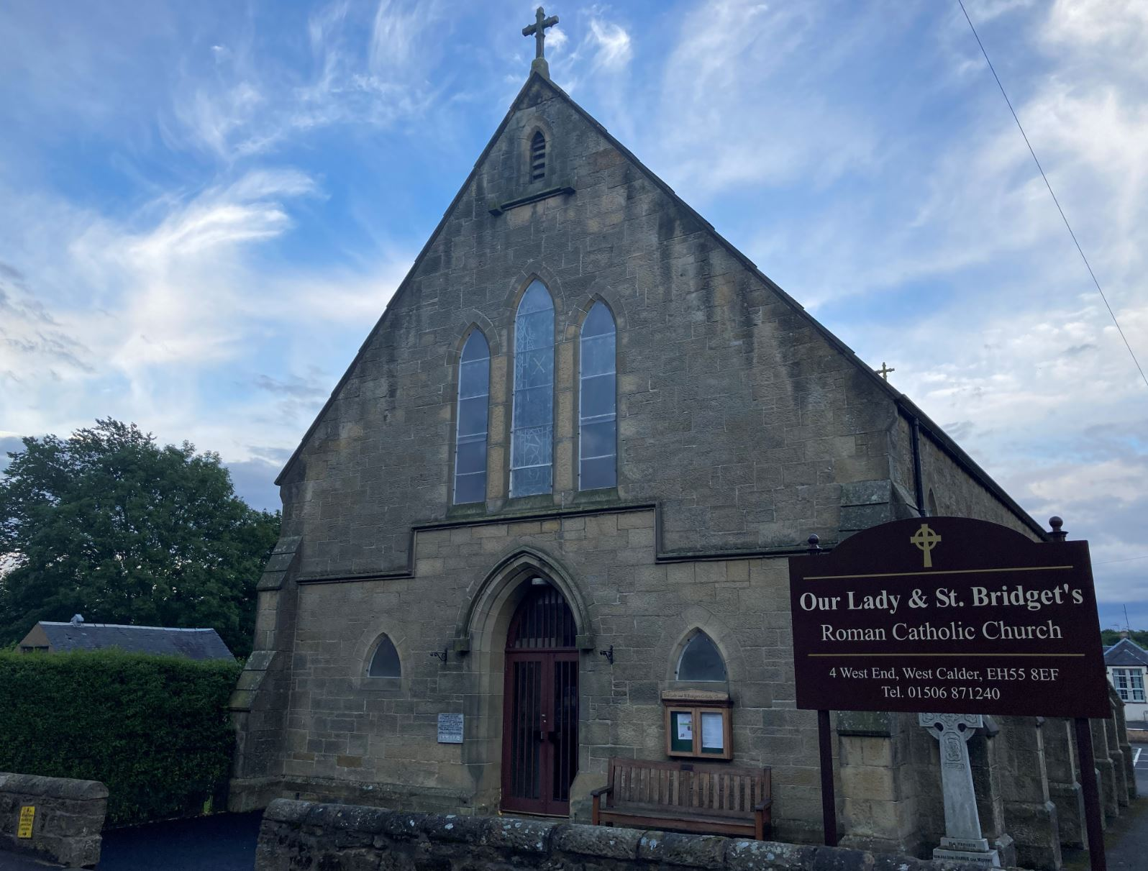

Please see the Parish Website for this document. http://www.westcaldercatholicchurch.org/

Contents
1 Liturgy 3
1.1 Children’s Liturgy 3
1.2 Extraordinary Minister of the Eucharist 3
1.3 Sacristan 4
1.4 Readers 4
1.5 Passkeeping 4
1.6 Music Ministry 5
1.7 Altar Servers 5
1.8 IT management of music equipment 5
2 Church Property 6
2.1 Church Cleaning 6
2.2 Church Gardens 6
2.3 Church Building Infrastructure 6
3 Community / Outreach 7
3.1 St Vincent de Paul (SVDP) 7
3.2 Pro-Life 7
4 Administration 8
4.1 Protection of Vulnerable Groups (PVG)/Safeguarding Coordinator 8
4.2 Gift Aid 8
4.3 Parish Pastoral Council 9
4.4 Collection Counting 9
5 Communication 10
5.1 Newsletter 10
5.2 Website 10
5.3 Internet Streaming 10
6 Social Activities 11
6.1 Social Events Team 11
7 Faith and Formation 12
7.1 Rite of Christian Initiation of Adults (RCIA) 12
7.2 Children’s Ministry 12
7.3 Youth Ministry 12

Liturgy

Children’s Liturgy
 | Children’s Liturgy
Role | To help the children of the parish reflect on the Gospel story through discussion, prayers, songs and other activities.
Duty | Two people lead the 20-minute session during mass.  Preparation of session is required beforehand using a Children’s Liturgy book and 5 minutes before and after mass is required to set up the alcove area i.e. arranging the chairs.
Skills / Talents | Willing and keen to work with children to share with them the Gospel
Training | Training and support can be provided by existing Children’s Liturgy team.
Commitment | You will be part of a team rota where the current commitment is to help once every 2 month.

Extraordinary Minister of the Eucharist

 | Extraordinary Minister of the Eucharist
Role | To serve the parish by assisting in the distribution of Holy Communion at daily and Sunday Mass and by taking the Eucharist to the sick and housebound in the community
Duty | This minister is commonly known as a `Eucharistic minister ` or `Special minister` of the Eucharist. It is a special lay ministry to assist the priest with the distribution of `Holy Communion` at Holy Mass and out with Mass as directed by the priest.  The person chosen by the priest will be in good standing within the Church, receive training and support and then be commissioned by the priest to serve the parish community.  It is a very rewarding ministry to be involved with and much appreciated by the priest and parish community.
Skills / Talents | The Eucharistic Minister is a confirmed Catholic in good standing with the Catholic Church. They must be commissioned to distribute the Eucharist.
Training | Training and ongoing support will be provided for this role.  The archdiocese will host formations days for this ministry.
Commitment | Your main Commitment will be part of a team rota where the current commitment is to help at weekend mass every 1-2 weeks

Sacristan
 | Sacristan
Role | To assist in the sacristy behind the scenes preparing the sacred vessels, books, vestments and candles etc,.
Duty | You will prepare the altar and the sanctuary for the different Liturgical Services. This assists the priest and allows him more time to prepare for the different Liturgical Services knowing that everything is in order.  This ministry is very rewarding and gives the person a greater insight into the different Liturgies in our Church Community and much appreciated by the priest.
Skills / Talents | Reliable  Needs to know the rudiments of the Mass
Training | Training will be provided for this role.
Commitment | You will be part of rota where the commitment is to prepare the alter for weekend Mass ever 1-2 weeks. Plus occasional funerals and wedding as per request.

Readers
 | Readers
Role | To deliver the Readings of The Mass
Duty | Readers should read over the readings beforehand.  At Mass, read the 1st Reading, Bidding Prayers and 2nd reading.
Skills / Talents | Ability to read fluently and speak clearly
Training | Training will be provided for this role.  The archdiocese will host formations days for this ministry.
Commitment | You will be part of rota where the commitment is help with weekend Mass ever 4-6 weeks.  A rota for readers will be drawn up every 4 months approximately with a separate one for Holy Week. Copies will be available at the back of the church.

Passkeeping
 | Passkeeping
Role | Welcome people as they come into mass
Duty | Arrive at least 30 minutes before the Mass; greet people as they arrive at church, give out information, escort worshippers to their seat, when required. They organise the offertory – taking the collection and inviting a small group of worshippers to bring the gifts to the altar in preparation for the Liturgy of the Sacrament. They also tidy up the missalette, hymn books and mass book following Mass.
Skills / Talents | Friendly and hospitable to welcome people as they attend mass
Training | Training and support will be provided for this role
Commitment | You will be part of rota where the commitment is to help with weekend mass. The current rota is ever 2-4 weeks. Plus occasionally Funerals or weddings per request.

Music Ministry
 | Music Ministry
Role | Play the Organ or take the lead in the singing of hymns during Mass
Duty | Assist with the selection of hymns before each mass.  Take lead in starting hymns.
Skills / Talents | Able to play organ  Ability to lead the singing of hymn. Familiarity with hymns.
Training
Commitment | Be willing to contribute at Sunday Masses/Liturgies.

Altar Servers
 | Altar Servers
Role | The primary role of the Altar Servers is to assist the priest in the celebration of the liturgy, especially during Mass.
Duty | Alter servers must have received their 1st Holy Communion.  Arrive about 20 minutes before Mass/Liturgy to put on alb and agree to various assignments.  Help clean up for about ten minutes after Mass/Liturgy.  Willing to be flexible during special masses/liturgies, and special requests from the priest/presider.
Skills / Talents | This ministry is open to anyone from children in primary school to adults.
Training | Training will be provided to fulfil the role.
Commitment | Be willing to serve at Sunday Masses/Liturgies.

IT management of music equipment
 | IT management of music equipment
Role | Support playing recorded music during Mass
Duty | Start and stop playing music during Mass
Skills / Talents | Capable of using technology.
Training | Support will be given to use the music box
Commitment | Attend Mass

Church Property

Church Cleaning
 | Church Cleaning
Role | Cleaning of church
Duty | A member of a team of 3-6 people clean the church. This involves washing the floor, dusting, vacuuming, cleaning glass, cleaning the toilet, empting bins etc.  Each cleaning session takes about 45 minutes. Cleaning can be done at a time that suits the team involved.
Skills / Talents | Physically able to be involved in the cleaning activities
Training | Support can be given by the existing cleaning team
Commitment | You will be part of a team rota where the current commitment is to help once every 2 month.

Church Gardens
 | Church Gardens
Role | Keeping the grounds of the church neat and tidy
Duty | Work as part of a team.  Cutting the grass and hedge in the church grounds
Skills / Talents | Physically able to help cut the grass
Training | Guidance will be given by the existing garden team
Commitment | Provide help during the garden growing season Spring – Autumn.  You will be part of a team rota where the current commitment is to help once every 2 month.

Finance and Fabric Committee
 | Finance and Fabric Committee
Role | Ensure the fabric of the church, house and grounds are maintained
Duty | Meet regularly to plan for any maintenance work that is required.  Arrange for work to be carried out.  Advice the Parish Priest in financial matters.
Skills / Talents
Training | Knowledge of accountancy and/or building experience
Commitment | As needed - at least twice a year plus being part of ongoing projects.

Flowers
 | Flowers
Role | Arrange flowers
Duty | Arrange and prepare the altar with flowers
Skills / Talents | Ability to arrange flowers
Training
Commitment | Prepare the altar with flowers on special occasions and when needed

Community / Outreach

St Vincent de Paul (SVDP)
 | St Vincent de Paul (SVDP)
Role | To deepen our Christian Sanctity by giving material help to the poor
Duty | As a SVDP member, you will visit the sick and lonely. The Society is Ecumenical and helps all members of the public. Our Society is also non-judgemental on the circumstances that have created the problems for the person in need.
Skills / Talents
Training | Assistance will be provided from current SVDP member to help fulfil this role
Commitment | You can visit the sick as frequently and for as long as you have available time. Visits can be on individual or in pairs

Pro-Life
 | Pro-Life Scotland
Role | Pro-Life
Duty | Make the parish aware of pro-live events and activities  Add posters in the porch for parishioners to see.
Skills / Talents | Keen interest in pro-life
Training
Commitment | Stay informed from Paul Atkin (Pro-Life)

Administration

Protection of Vulnerable Groups (PVG)/Safeguarding Coordinator
 | Protection of Vulnerable Groups
Role | The PVG/Safeguarding assess the needs of the parish with regard to safeguarding.
Duty | The duties associated with the PSC’s role will take account of the circumstances of each Parish and will be undertaken or delegated by the Parish Priest having assessed the needs of the Parish.  Be conversant with the information contained within In God’s Image and feel confident in a working knowledge of the document.  Register on the SCSS website for access to the Resources Section.  Attend the mandatory training for new PSCs and any other appropriate training provided by the Diocese.
Skills / Talents | Reliable.  A good communicator.  Trustworthy.  Discreet.  Sensitive to the needs of vulnerable individuals and groups.  Prepared to seek advice and support appropriately.  Able to evidence good healthy boundaries.  Familiar with safeguarding policies and know how to implement them.  A person of faith, and specifically a practising Catholic, willing to witness to the Gospel in all they do.
Training | https://www.scsafeguarding.org.uk/  Assistance will be given to volunteers wishing to work with children or vulnerable adults, as there is an obligation to become a member of the Archdiocesan Protection of Vulnerable Groups (PVG) Scheme under the Protection of Vulnerable Groups (Scotland) Act 2007.
Commitment

Gift Aid
 | Gift Aid
Role | Assist with gift aid applications for the parish
Duty | Monitor envelopes, order envelopes and Gift Aid application forms
Skills / Talents | Organised and committed to supporting the Gift aid process.
Training | Supported given
Commitment | Generate a report once a year.

Parish Pastoral Council
 | Parish Pastoral Council
Role | The Parish Council exists to assist the parish priest in all matters relating to the pastoral life of the parish.
Duty | Meet on a regular basis to discuss the life of the parish.
Skills / Talents | Open communicator  Active member of the parish community
Training | No special training is needed.
Commitment | Meet about 4-6 times over the year

Collection Counting
 | Collection Counting
Role | Count the offertory collection money
Duty | On a weekly basis, after Sunday Mass, count the collection money
Skills / Talents | Comfortable working with cash.
Training | No special training will be required. The counting team will support.
Commitment | Available to count money after Sunday Mass.

Communication

Newsletter
 | Newsletter
Role | Keeping good communication with the community via weekly newsletter
Duty | Gathering information, editing, printing.
Skills / Talents | Word processing capabilities.
Training | Basic knowledge of the internet, computers and MS Office required
Commitment | Produce the parish newsletter once a week in cooperation with the Parish Priest

Website
 | Website
Role | Maintain Website
Duty | Keep website fresh and up to date
Skills / Talents | Ability to use a computer and basic editing of web pages.
Training | Overview the website and how to edit will be provided.
Commitment | Weekly update of the website to upload the newsletter.  Other website updates as required.

Internet Streaming
 | Internet Streaming
Role | Stream mass service to the internet
Duty | Arrive 20 minutes before mass,  Start streaming to the internet before Mass. Stop streaming after mass.
Skills / Talents | Aware of technologies and use of mobile phone.
Training | Guidance will be provided
Commitment | Based on a rota, every few weeks.

Social Activities

Social Events Team
 | Social Events Team
Role | Social Events Team
Duty | Plan social events  Help in the running of any events
Skills / Talents | Well organised  Willing to participate
Training | Support will be provided by the team
Commitment | Arrange and support events as needed.

Faith and Formation

Rite of Christian Initiation of Adults (RCIA)
 | Rite of Christian Initiation of Adults (RCIA)
Role | Share witness to the faith with candidate aspiring to join the Catholic Church community.
Duty | Assist the Parish Priest in organising the catechetical meetings.
Skills / Talents | Background of RE Religious education and/or willingness to learn and explore our faith from basics to current challenging subjects
Training
Commitment | One meeting a week during the RCIA class. October to May.

Children’s Ministry
 | Children’s Liturgy
Role | To help the children of the parish reflect on the Gospel story through discussion, prayers, songs and other activities.
Duty | Two people lead the 20-minute session during mass.  Preparation of session is required beforehand using a Children’s Liturgy book and 5 minutes before and after mass is required to set up the alcove area i.e. arranging the chairs.
Skills / Talents | Willing and keen to work with children to share with them the Gospel
Training | Training and support can be provided by existing Children’s Liturgy team.
Commitment | You will be part of a team rota where the current commitment is to help once every 2 month.

Youth Ministry
 | Youth Ministry
Role | To enrich the spiritual life of the youth people of the parish.
Duty | Youth Ministry (16 – 25+)  There is currently no youth ministry in the parish. If you would like to assist in forming this ministry, please contact Fr Marcin or a member of the Parish Council.  The parish values highly the spiritual wellbeing of its young people who are its future.
Skills / Talents | If you have the gift of working well with young people, the parish will appreciate your involvement in this effort.
Training
Commitment

